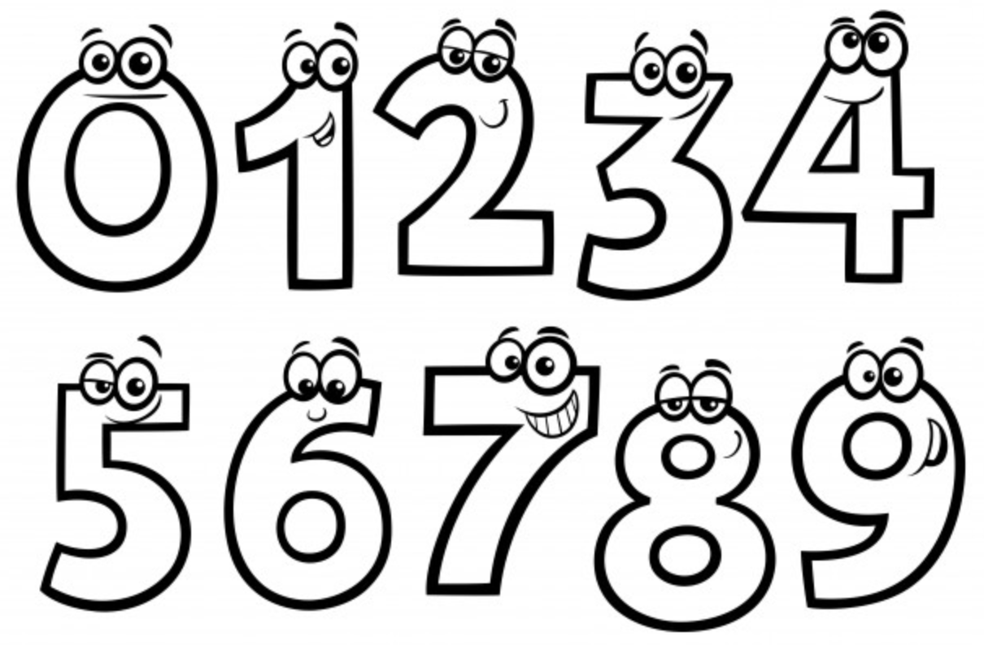
Code / Project : CME1252 / 2
Year / Semester : 2018-2019 Spring Semester
Duration : 5 weeks

Project: Numbers

The aim of the project is to develop a game in which players
try to reach the target number in limited time.

General Information

Game is played with two players: human player and computer. A random target number between 100-999 is determined initially. Players will try to reach/approach this target number in 30 seconds. Players use five random small numbers between 1-9, and one big random number (25, 50, 75 or 100) and 4 basic operations (* / + -) to reach this target.

Game Playing Rules/Stages

1. Target number is chosen randomly (100-999).
2. Five small numbers are chosen randomly (1-9).
3. One big number is chosen randomly (25/50/75/100).
4. 30-second countdown starts.
5. During this time, human player makes calculations in his mind or with pen and paper. Computer tries to reach the target by using random operations with randomly chosen numbers.
6. Rules for operations:
- Players can use each number only once (given or calculated).
- Players do not have to use all the numbers.
- For division operation, integer division will be used.
- If parenthesis are not used, multiplication and division have higher priority. Operations which have the same priority are calculated from left to right.
7. When the time is up, players will announce their result numbers.
8. The player with the closest number explains how he reached this number.
9. If the explanation is correct, he gets the point; if it is wrong, then his opponent gets that point.
10. The one who reaches 100 points first wins the game.

Explanation of the Operations

If the human is the closest to the target number, he enters an infix expression. This expression must first be transformed to postfix expression, then this postfix expression must be evaluated. Stages of the transformation/evaluation must be shown on the screen step by step.

If the computer player is the closest to the target number, it displays each operation used on the screen.

Scoring

If the difference is less than or equals to 10; point = 15 - Abs(TargetNumber - CalculatedNumber)
If the difference is greater than 10; point = 5

Sample Game and Screens

--- Round 1 ----------------------

Target Number: 860

Numbers: 9 6 4 9 1 75

Duration: 30 29 28 27 26 25 24 23 22 21 20 19 18 17 16 15 14 13 12 11 10 9 8 7 6 5 4 3 2 1 0

----------------------------------

Result numbers
Player: 859 Computer: 862

Enter player's solution: 1+6*9/4*(75-9)

Infix to postfix conversion steps:

Step 1 - 1+6*9/4*(75-9)  1  | |  | |  | |  | |  | + |  ----- | Step 2 - 1+6*9/4*(75-9)  1 6  | |  | |  | |  | * |  | + |  ----- | Step 3 - 1+6*9/4*(75-9)  1 6 9 *  | |  | |  | |  | / |  | + |  -----
Step 4 - 1+6*9/4*(75-9)  1 6 9 * 4 /  | |  | |  | |  | * |  | + |  ----- | Step 5 - 1+6*9/4*(75-9)  1 6 9 * 4 /  | |  | |  | ( |  | * |  | + |  ----- | Step 6 - 1+6*9/4*(75-9)  1 6 9 * 4 / 75  | |  | - |  | ( |  | * |  | + |  -----
Step 7 - 1+6*9/4*(75-9)  1 6 9 * 4 / 75 9 -  | |  | |  | |  | * |  | + |  ----- | Step 8 - 1+6*9/4*(75-9)  1 6 9 * 4 / 75 9 - * +  | |  | |  | |  | |  | |  -----

Postfix expression:

1 6 9 * 4 / 75 9 - * +

Postfix evaluation steps:

Step 1  1 6 9 * 4 / 75 9 - * +  | |  | |  | 9 |  | 6 |  | 1 |  ----- | Step 2  1 6 9 * 4 / 75 9 - * +  | |  | |  | |  |54 |  | 1 |  ----- | Step 3  1 6 9 * 4 / 75 9 - * +  | |  | |  | 4 |  |54 |  | 1 |  -----
Step 4  1 6 9 * 4 / 75 9 - * +  | |  | |  | |  |13 |  | 1 |  ----- | Step 5  1 6 9 * 4 / 75 9 - * +  | |  | 9 |  |75 |  |13 |  | 1 |  ----- | Step 6  1 6 9 * 4 / 75 9 - * +  | |  | |  |66 |  |13 |  | 1 |  -----
Step 7  1 6 9 * 4 / 75 9 - * +  | |  | |  | |  |858|  | 1 |  ----- | Step 8  1 6 9 * 4 / 75 9 - * +  | |  | |  | |  | |  |859|  -----

Result: 859

--- Correct

Player Score : 14
Computer Score: 0

--- Round 2 ----------------------

Target Number: 570

Numbers: 7 3 2 5 3 100

Duration: 30 29 28 27 26 25 24 23 22 21 20 19 18 17 16 15 14 13 12 11 10 9 8 7 6 5 4 3 2 1 0

----------------------------------

Result numbers
Player: 573 Computer: 570

Computer's solution steps:
2 * 7 = 14
3 * 3 = 9
100 + 14 = 114
5 * 114 = 570

--- Correct

Player Score : 14
Computer Score: 15

...

Suggested Weekly Program

1. Design of classes and data structures, screen, random numbers, timing.
2. Human player answer. Infix to postfix conversion steps.
3. Postfix evaluation steps.
4. Computer AI.
5. Computer solution steps. Remaining parts of the game, testing.

First Evaluation: 5.4.2019  Report: 5.4.2019 | Final Evaluation: 19.4.2019 (presentation in English: powerpoint+poster)  Report: 22.4.2019

